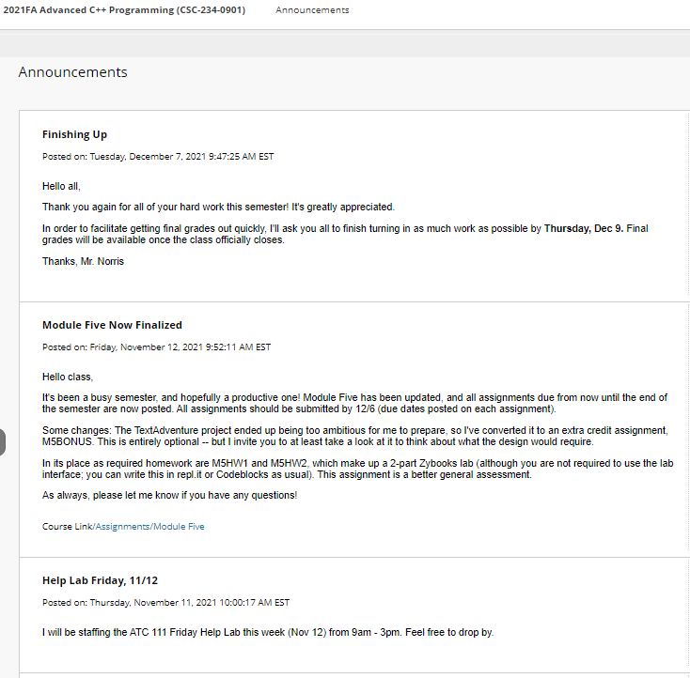

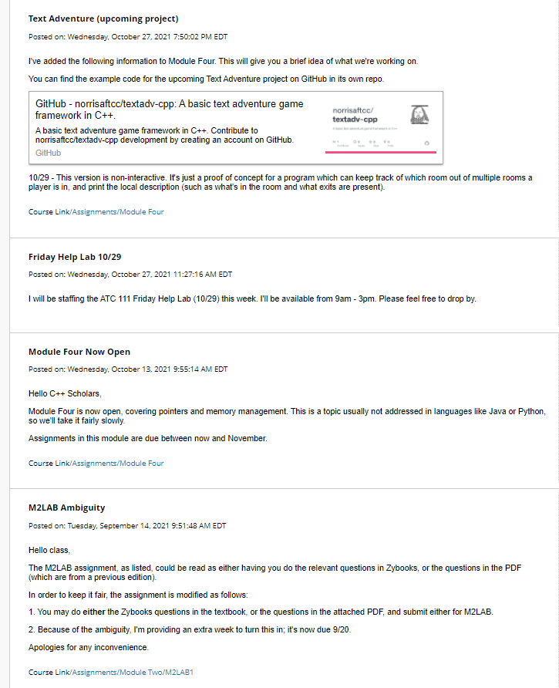

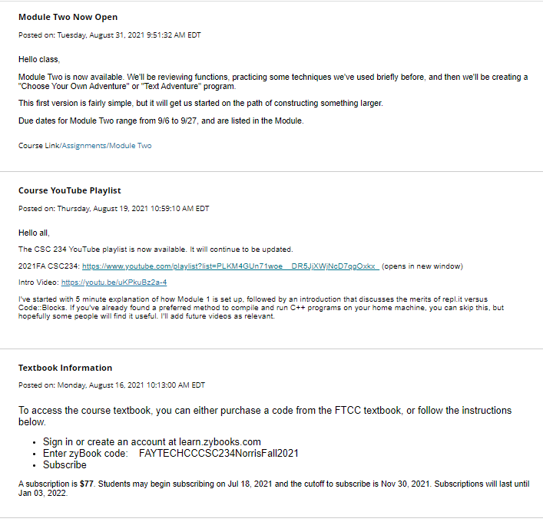

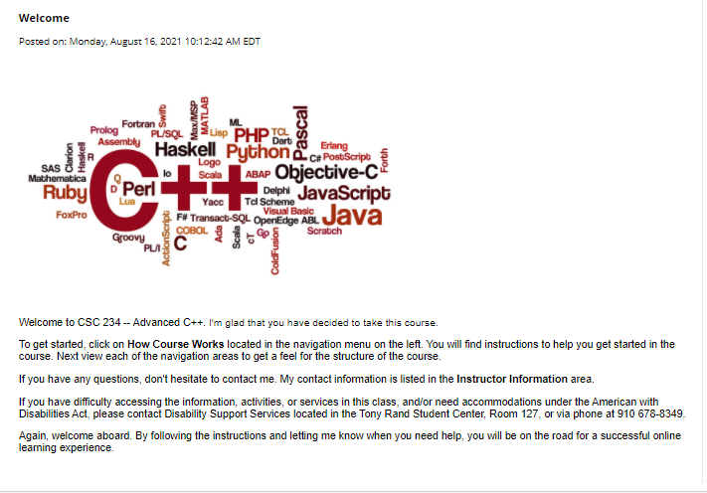

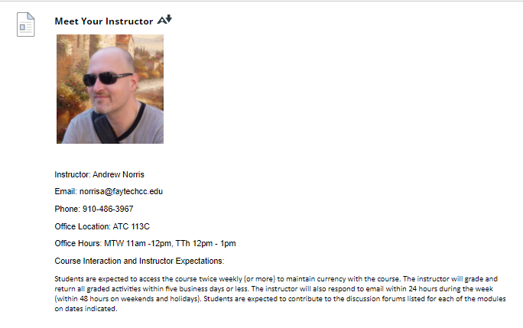

Announcements

Top of Form

* **Finishing Up**

Posted on: Tuesday, December 7, 2021 9:47:25 AM EST

Hello all,

Thank you again for all of your hard work this semester! It's greatly appreciated.

In order to facilitate getting final grades out quickly, I'll ask you all to finish turning in as much work as possible by **Thursday, Dec 9.** Final grades will be available once the class officially closes.

Thanks, Mr. Norris

Posted by: Andrew Norris

Posted to: 2021FA Advanced C++ Programming (CSC-234-0901)

* **Module Five Now Finalized**

Posted on: Friday, November 12, 2021 9:52:11 AM EST

Hello class,

It's been a busy semester, and hopefully a productive one! Module Five has been updated, and all assignments due from now until the end of the semester are now posted. All assignments should be submitted by 12/6 (due dates posted on each assignment).

Some changes: The TextAdventure project ended up being too ambitious for me to prepare, so I've converted it to an extra credit assignment, M5BONUS. This is entirely optional -- but I invite you to at least take a look at it to think about what the design would require.

In its place as required homework are M5HW1 and M5HW2, which make up a 2-part Zybooks lab (although you are not required to use the lab interface; you can write this in repl.it or Codeblocks as usual). This assignment is a better general assessment.

As always, please let me know if you have any questions!

Course Link[/Assignments/Module Five](https://faytechcc.blackboard.com/webapps/blackboard/content/launchLink.jsp?ann_id=_524838_1&course_id=_33824_1&mode=view)

Posted by: Andrew Norris

Posted to: 2021FA Advanced C++ Programming (CSC-234-0901)

* **Help Lab Friday, 11/12**

Posted on: Thursday, November 11, 2021 10:00:17 AM EST

I will be staffing the ATC 111 Friday Help Lab this week (Nov 12) from 9am - 3pm. Feel free to drop by.

Posted by: Andrew Norris

Posted to: 2021FA Advanced C++ Programming (CSC-234-0901)

* **Text Adventure (upcoming project)**

Posted on: Wednesday, October 27, 2021 7:50:02 PM EDT

I've added the following information to Module Four. This will give you a brief idea of what we're working on.

You can find the example code for the upcoming Text Adventure project on GitHub in its own repo.

[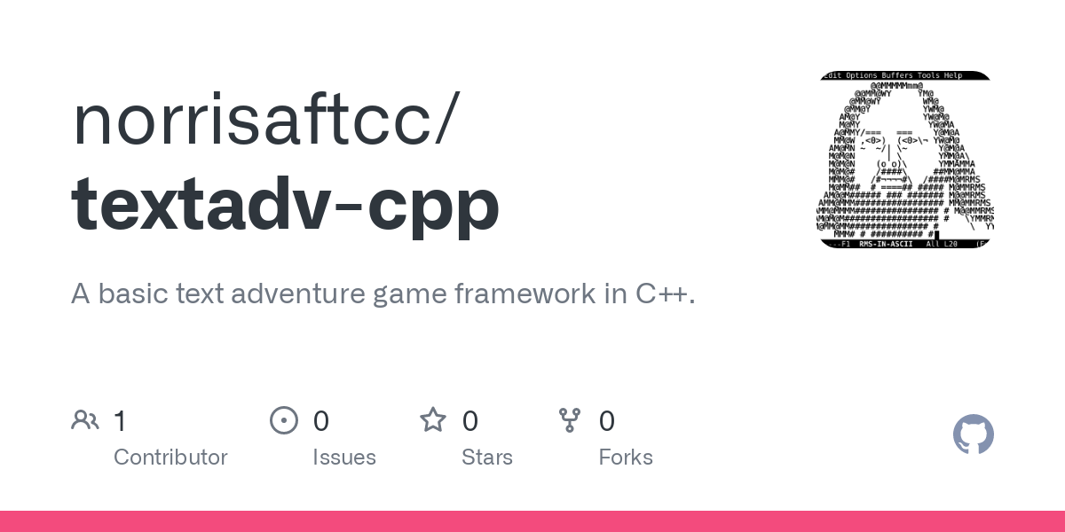GitHub - norrisaftcc/textadv-cpp: A basic text adventure game framework in C++.A basic text adventure game framework in C++. Contribute to norrisaftcc/textadv-cpp development by creating an account on GitHub.GitHub](https://github.com/norrisaftcc/textadv-cpp)

10/29 - This version is non-interactive. It's just a proof of concept for a program which can keep track of which room out of multiple rooms a player is in, and print the local description (such as what's in the room and what exits are present).

Course Link[/Assignments/Module Four](https://faytechcc.blackboard.com/webapps/blackboard/content/launchLink.jsp?ann_id=_521885_1&course_id=_33824_1&mode=view)

Posted by: Andrew Norris

Posted to: 2021FA Advanced C++ Programming (CSC-234-0901)

* **Friday Help Lab 10/29**

Posted on: Wednesday, October 27, 2021 11:27:16 AM EDT

I will be staffing the ATC 111 Friday Help Lab (10/29) this week. I'll be available from 9am - 3pm. Please feel free to drop by.

Posted by: Andrew Norris

Posted to: 2021FA Advanced C++ Programming (CSC-234-0901)

* **Module Four Now Open**

Posted on: Wednesday, October 13, 2021 9:55:14 AM EDT

Hello C++ Scholars,

Module Four is now open, covering pointers and memory management. This is a topic usually not addressed in languages like Java or Python, so we'll take it fairly slowly.

Assignments in this module are due between now and November.

Course Link[/Assignments/Module Four](https://faytechcc.blackboard.com/webapps/blackboard/content/launchLink.jsp?ann_id=_518456_1&course_id=_33824_1&mode=view)

Posted by: Andrew Norris

Posted to: 2021FA Advanced C++ Programming (CSC-234-0901)

* **M2LAB Ambiguity**

Posted on: Tuesday, September 14, 2021 9:51:48 AM EDT

Hello class,

The M2LAB assignment, as listed, could be read as either having you do the relevant questions in Zybooks, or the questions in the PDF (which are from a previous edition).

In order to keep it fair, the assignment is modified as follows:

1. You may do **either** the Zybooks questions in the textbook, or the questions in the attached PDF, and submit either for M2LAB.

2. Because of the ambiguity, I'm providing an extra week to turn this in; it's now due 9/20.

Apologies for any inconvenience.

Course Link[/Assignments/Module Two/M2LAB1](https://faytechcc.blackboard.com/webapps/blackboard/content/launchLink.jsp?ann_id=_511122_1&course_id=_33824_1&mode=view)

Posted by: Andrew Norris

Posted to: 2021FA Advanced C++ Programming (CSC-234-0901)

* **Module Two Now Open**

Posted on: Tuesday, August 31, 2021 9:51:32 AM EDT

Hello class,

Module Two is now available. We'll be reviewing functions, practicing some techniques we've used briefly before, and then we'll be creating a "Choose Your Own Adventure" or "Text Adventure" program.

This first version is fairly simple, but it will get us started on the path of constructing something larger.

Due dates for Module Two range from 9/6 to 9/27, and are listed in the Module.

Course Link[/Assignments/Module Two](https://faytechcc.blackboard.com/webapps/blackboard/content/launchLink.jsp?ann_id=_508635_1&course_id=_33824_1&mode=view)

Posted by: Andrew Norris

Posted to: 2021FA Advanced C++ Programming (CSC-234-0901)

* **Course YouTube Playlist**

Posted on: Thursday, August 19, 2021 10:59:10 AM EDT

Hello all,

The CSC 234 YouTube playlist is now available. It will continue to be updated.

2021FA CSC234: <https://www.youtube.com/playlist?list=PLKM4GUn71woe__DR5JjXWjNcD7qgOxkx_> (opens in new window)

Intro Video: <https://youtu.be/uKPkuBz2a-4>

I've started with 5 minute explanation of how Module 1 is set up, followed by an introduction that discusses the merits of repl.it versus Code::Blocks. If you've already found a preferred method to compile and run C++ programs on your home machine, you can skip this, but hopefully some people will find it useful. I'll add future videos as relevant.

Posted by: Andrew Norris

Posted to: 2021FA Advanced C++ Programming (CSC-234-0901)

* **Textbook Information**

Posted on: Monday, August 16, 2021 10:13:00 AM EDT

To access the course textbook, you can either purchase a code from the FTCC textbook, or follow the instructions below.

* + Sign in or create an account at learn.zybooks.com
  + Enter zyBook code:    FAYTECHCCCSC234NorrisFall2021
  + Subscribe

A subscription is **$77**. Students may begin subscribing on Jul 18, 2021 and the cutoff to subscribe is Nov 30, 2021. Subscriptions will last until Jan 03, 2022.

Posted by: Andrew Norris

Posted to: 2021FA Advanced C++ Programming (CSC-234-0901)

* **Welcome**

Posted on: Monday, August 16, 2021 10:12:42 AM EDT

Welcome to CSC 234 -- Advanced C++. I'm glad that you have decided to take this course.

To get started, click on **How Course Works** located in the navigation menu on the left. You will find instructions to help you get started in the course. Next view each of the navigation areas to get a feel for the structure of the course.

If you have any questions, don't hesitate to contact me. My contact information is listed in the **Instructor Information** area.

If you have difficulty accessing the information, activities, or services in this class, and/or need accommodations under the American with Disabilities Act, please contact Disability Support Services located in the Tony Rand Student Center, Room 127, or via phone at 910 678-8349.

Again, welcome aboard. By following the instructions and letting me know when you need help, you will be on the road for a successful online learning experience.

Bottom of Form